ECBACC, Inc.
Office: 267.536.9847
Mobile: 908.334.1793
CONTACT:
Shenkarr Davis, GCA Cmte Chair
E-mail: shenkarr.davis@ecbacc.com
or
Akinşeye Brown, Vice-President
E-mail: akinseye.brown@ecbacc.com

For Immediate Release
May 1, 2026

The 21st Annual Glyph Comics Awards (GCA) Celebrates Excellence in the Industry

FREE On-Line Event

Philadelphia, PA - “The City of Firsts” - Philly has long been recognized as a place that has provided fertile ground for a number of artistic efforts, including music, dance, mural-making, storytelling and comic book creation. In fact, brothers Orrin and George Evans created the first Black comic book in Philadelphia in 1947: All-Negro Comics #1. The East Coast Black Age of Comics Convention (ECBACC, Inc.) aka ECBACC Philly, the first full-service Comic Book Convention and the model for community-based comic book conventions, diversi-cons and ethno-cons, has successfully cultivated balanced images of Africana [Black] superheroes, and has served as a nexus, conduit and catalyst for Black comic book creators, their colleagues and fans since 2002. For the past 25 years, ECBACC has paid tribute to this important legacy, promoted the work of veteran as well as up-and-coming artists, and served as a wellspring of collaborative efforts among comic book creators. “The place to meet and network with Black comic book publishers, artists, writers, their colleagues and their fans is at ECBACC,” says ECBACC, Inc. Vice-President and Event Coordinator Mr. Akinşeye Brown. “ECBACC is the place to be.”

The 21st Annual Glyph Comics Awards (GCA), the nation’s first international award of its kind, will be hosted on-line on Saturday, May 9, 2026, from 3p.m. – 4:30p.m., a week before the full Convention at The Temple University Student Faculty Center / 3340 N. Broad St. The Glyphs recognizes the best in Black-themed comic books, comic strips, web-comics and graphic novels. Categories include: Best Artist, Best Writer, Best Cover, Best Comic Strip or Web-Comic, Best Female Character, Best Male Character, Rising Star, Best Reprint Publication, Story of the Year, and Fan Award for Best Comic. While it is not exclusive to Black creators, it does strive to honor those who have made the greatest contributions to the comic book medium in terms of both critical and commercial impact.

Who will take home the Glyph Award medallion this year? Join us on-line on Saturday, May 9, 2026 / 3p.m. – 4:30p.m. to find out. Log-in details will be posted on our social media platforms to facilitate access for / to our international audience and those stateside who cannot attend in person.

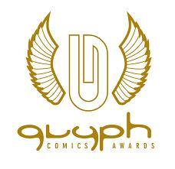
For more information, the full list of Convention panelists & artists, visit: www.ecbacc.com
The 21st Annual Glyph Comics Awards (GCA) Celebrates Excellence in the Industry

On-Line: Saturday, May 9, 2026, from 3p.m. – 4:30p.m.

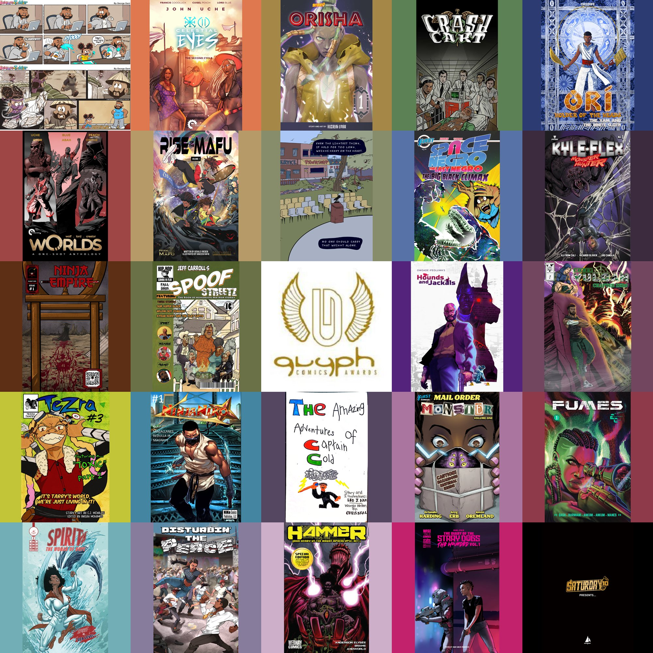

the GCA Awards Program will be on-line

The 21st Annual Glyph Comics Awards (GCA), the nation’s first international award of its kind, will be hosted on-line on Saturday, May 9, 2026, from 3p.m. – 4:30p.m., a week before the full Convention at The Temple University Student Faculty Center / 3340 N. Broad St. The Glyphs recognizes the best in Black-themed comic books, comic strips, web-comics and graphic novels. Categories include: Best Artist, Best Writer, Best Cover, Best Comic Strip or Web-Comic, Best Female Character, Best Male Character, Rising Star, Best Reprint Publication, Story of the Year, and Fan Award for Best Comic. While it is not exclusive to Black creators, it does strive to honor those who have made the greatest contributions to the comic book medium in terms of both critical and commercial impact.

Who will take home the new Glyph Award medallion this year? Join us on-line on Saturday, May 9, 2025 / 3p.m. – 4:30p.m. to find out. Log-in details will be posted on our social media platforms to facilitate access for / to our international audience and those stateside who cannot attend in person.
For more information, the full list of Convention panelists & artists, visit: www.ecbacc.com

